## C:\Users\HPPAVILION23KPTM\Desktop\Logo KUPTM dan Color Code.jpg

FKLT/12-00

Assignment Cover– be sure to keep a copy of all work submitted

##### To be completed by student – PLEASE PRINT CLEARLY

|  |  |  |  |
| --- | --- | --- | --- |
| Name:  Nordiana binti Abdull Rahman  Aina Fareena binti Mohd Fadzil  Nur Hidayah Bt Samsudin  Ahmad Nadzrin Bin Ibrahim | | | |
| ID Number:  AM1709003250  AM1709002964  AM1709003232  AM1709003257 | | | |
| Lecturer  Nor Azura Salleh @ Omar / Mohamed Ghazali bin Khairuzzaman | | Lab group / Tutorial group / Tutor (if applicable) |
| Course and Course Code  CSC406–Web API | | Submission Date:  **5/4/2019** |
| Assignment No. / Title  Report AdamHawa.com | | Extension & Late submission:  Allowed / Disallowed |
| Assignment type:  Group | % of Assignment Mark | Returning Date: | |
| Penalties:   1. 10% of the original mark will be deducted for every one week period after the submission date 2. No work will be accepted after two weeks of the deadline 3. If you were unable to submit the coursework on time due to extenuating circumstances you may be eligible for an extension 4. Extension will not exceed one week | | |
| Declaration: I/we the undersigned confirm that I/we have read and agree to abide by these regulations on plagiarism and cheating. I/we confirm that this piece of work is my/our own. I/we consent to appropriate storage of our work for checking to ensure that there is no plagiarism/ academic cheating.  NORDIANA  NUR HIDAYAH  AINA FAREENA    NADZRIN  Signature:  Full Name: | | |

Table of Contents

1.0 Introduction 3

2.0 Services 4

3.0 Competitive Advantage 5

3.1 Differential leadership 5

3.2 Benefit 6

4.0 Process of AdamHawa.com 7

4.1 Flow Chart of AdamHawa.com 7

4.2 Work Breakdown Structure (WBS) 9

4.3 Business Process Model and Notation (BPMN) 10

4.4 Entity Relationship Diagram (ERD) 14

5.0 References 15

Appendix 16

# Introduction

The internet should be used to complement a traditional business strategy in establishing business-to-customer (B2C) relationships, and this is especially true for the online dating industry. Web-enabled technology does not remove the need to create a sustainable competitive advantage, and does not change the structure of an industry.

AdamHawa.com is a dating site for those out there who are still looking for a life partner to equip themselves in building a family of sakinah. Apart from that, AdamHawa.com is also a dating site dating to the Malay Muslim community in Malaysia. AdamHawa.com claim to be a world destination for casual dating, and are full of features that give you a lot of choices, from the way you discover others, the way you plan your profile.

As we know, every day thousands of people out there are looking for their partners and are serious about establishing relationships. The advantage of making a profile at AdamHawa.com is that you can personally determine the criteria your desired partner, the fun and sincere devoted to your love as it is. Hence, relationships may be more fun because you both share the same personality point.

With members who hit thousands of people, your search for your matchmaking is easier and more effective on this portal than just looking for or waiting for a "traditional" party out there. You will see, very many participants in the portal are composed of those who work, educate, look attractive and serious to get married. We are committed to helping you find the perfect match, no matter where in the world you may be.

It is estimated that in Year 1, more than 1000 couples have established a married after searching for their spouse on AdamHawa.com's website. AdamHawa.com now has more than eight years of experience in bringing together really serious couples in setting up a home.

Since there is no need for a middleman, AdamHawa.com put themselves out of business by conducting business online. There are at least two ways to ensure profitability, which are essentially the same for both traditional and internet influenced companies. Profitability results from operational effectiveness such as doing the same things better or through strategic positioning like doing things differently with a unique fit among processes that makes imitation difficult.

# Services

Online dating services are the latest and, perhaps one of the most controversial, businesses to benefit directly from the internet revolution. The internet’s ability literally to reach millions of people, from anywhere in the world, day or night, has helped propel the online dating industry into a multibillion-dollar love story for e-commerce customers. This success story has been based on a customer base whose needs were not properly being met under the traditional matchmaking methods. The apparent success of the online dating phenomenon is partially based on a conscious attempt to overcome customer misgivings that plagued more traditional dating services. This latest attempt at strategically leveraging the Web has spawned an affordable, convenient, and reliable matchmaking service to the masses.

The services offered by AdamHawa.com include the project of finding a partner as a whole, starting from finding the appropriate pairing criteria until they decide to set up a marriage. This service includes searching for couples that match the criteria you want and this service is open to Muslims Malaysian citizens aged 18 and above, either single, widowed or widowed and serious in finding a mate. Apart from that, AdamHawa.com provides affordable and attractive wedding packages for couples who will set up a marriage through AdamHawa.com.

AdamHawa.com also always finds the right partner for you and your personal data like your real name and phone number are hidden before you know your partner. Your personal profile is specific to registered and paid users only at AdamHawa.com. Registered but non-paid users cannot see in your personal profile details.

For those who are really serious in finding a partner, they need to upgrade their account to premium accounts before allowing them to start finding partners. The subscription price is very affordable because AdamHawa.com offers as low as RM100 for a lifetime. This is a premium account that has no time limit and this allows them to find their desired partners easily, but they can also easily get their favourite personal data.

In addition, there are other premium account options such as 6-month premium account as low as RM40, where by upgrading the 6-month premium account, users can only access the accounts they want to be limited to ten people and will be active for six months.

# Competitive Advantage

## Differential leadership

With differentiation leadership, the business targets a larger market and aims to achieve competitive advantage across the industry. This strategy involves choosing one or more criteria used by buyers in the market - and then putting the business uniquely to meet those criteria. This strategy is usually associated with imposing premium pricing on products - often reflecting higher production costs and additional features available to users.

Differentiation is about charging more premium prices than incurring additional production costs, and giving customers a clear reason to choose products from others, less-distinguished products.

Table 3.0: The three account that available in AdamHawa.com

AdamHawa.com give the subscription price is very affordable than others Online Dating System that available in Malaysia. So, with this price and some special features that AdamHawa.com gives to people who want to find their partners, here is the best place to do that.

## Benefit

When users used our service, they are buying the benefit that it gives them. It may be that our product makes their life simpler, and our service helps them to feel better about themselves to get their partners in life.

# Process of AdamHawa.com

## Flow Chart of AdamHawa.com

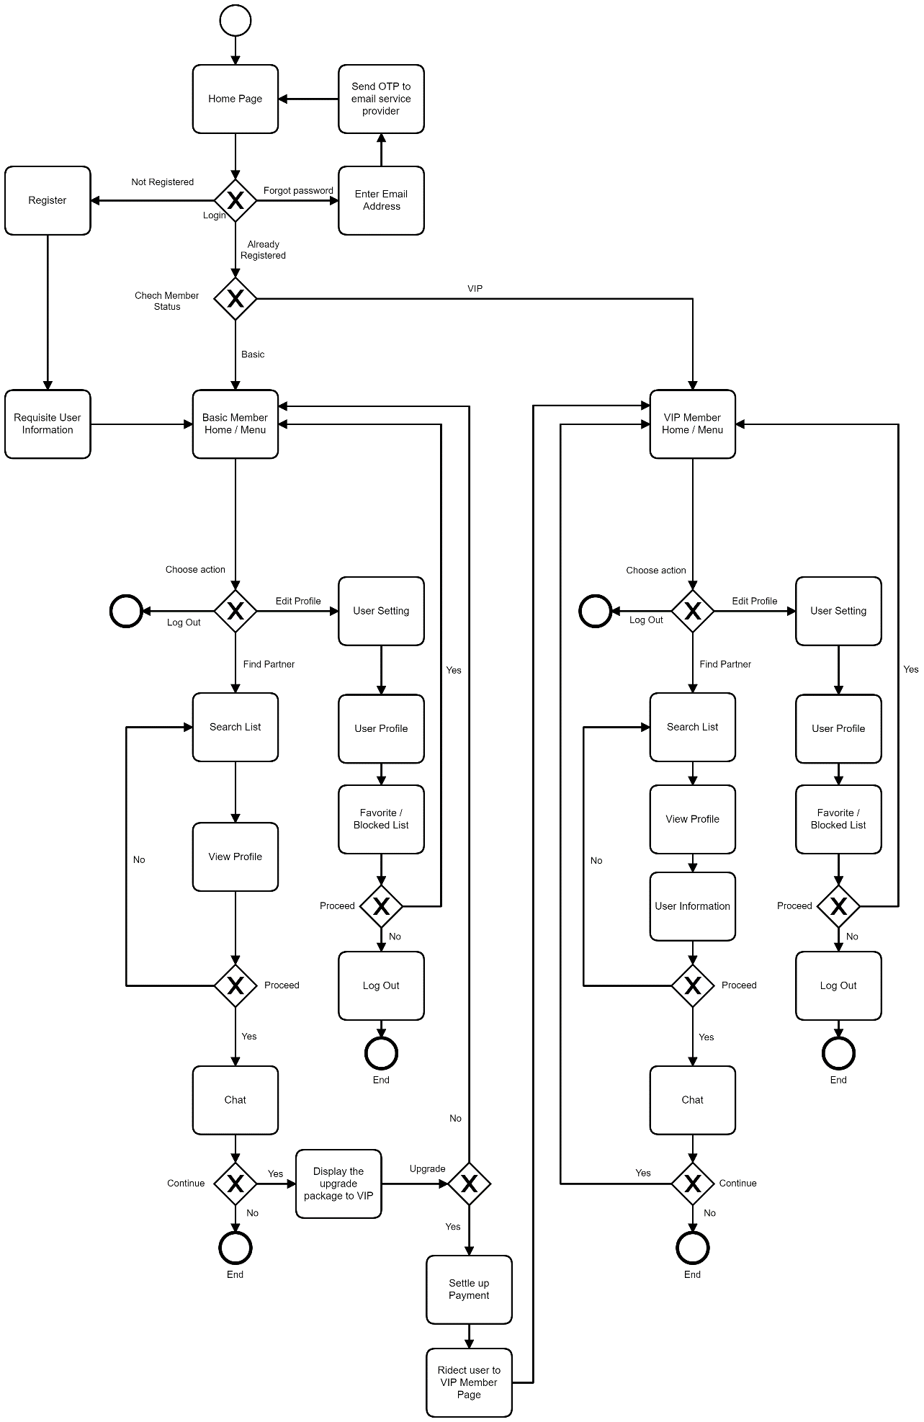

Figure 4.0: Flowchart of AdamHawa.com

First of all, open the website the user will see the homepage then if the user are newbie he/she need to register first than fill the user information and set the password also email than it will go to home or menu. If the user already registers in the website, the website will check your status member such as VIP or Basic member. While, if the user forget their password can click the Forgot Password and the user need write the email address than the website automatic send the OTP to the email service provider than the user can login as usual.

However, if the user just gets a basic member the user can choose their action such as edit their profile, find their partner or log out from their account. If the user choose to find their partner they can search list of the member are sign in where this website. Then, if the user has found their partner they can view the profile of the partner that has been chosen. After that, the user can proceed to chat with the partner that has chosen. Also if the user like that partner that their found then it will continue if the user want to upgrade the package or not. Then, if the user wants to upgrade their package they need to settle the payment. After settle the payment the user are will change to the user VIP member page. If the user does not want to proceed to chat with that partner it will go back to partner search list. Besides, if the user choose and want to edit the profile it will go to user setting than go to the user profile. In user profile, the user can choose that member as your favourite or you can block the list of the partner. If proceed then choose yes then it will go to home/menu. If the user chooses no it will log out and end the process.

Besides, if the user are register as a VIP member the user can search list of the partner are register will this website also can do same as basic member but in the find the partner then can view the profile of the partner and also view the user information then it up to the user want to proceed with the partner or not. If yes the user can chat with the partner that has been choose and the other process are same as the basic member. The different between VIP and Basic member are the user can view the user information such as phone number and else.

## 4.2 Work Breakdown Structure (WBS)

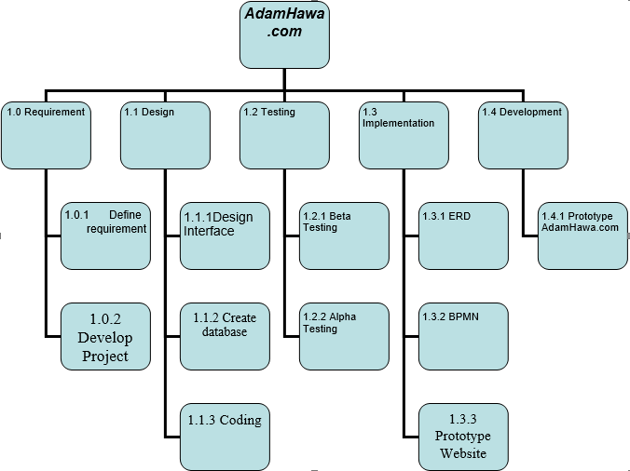

Figure 4.1: Work Breakdown Structure (WBS)

## 4.3 Business Process Model and Notation (BPMN)

Figure 4.2: Business Process Model and Notation (BPMN)

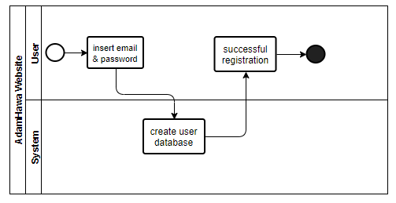

Figure 4.3: User Registration

First, the users will start to login their account or register their account to the new users. The process of registration is shown as in figure 4.3 and for the process login as in figure 4.4. On this part, the users can update their personal profiles such as their location, gender, age, physical attributes, race, religion, and preferences for these characteristics in a potential mate or date; a private messaging system.

On AdamHawa.com, the users need to choose either they want to upgrade their account or still go through with the basic account which is free account. If the user still with their basic account, so they cannot see your personal profile details. But, with the users that choose to pay for premium account, either they choose the lifetime account or 6 month subscription, they can search, matching and private messaging with our favourite partners.

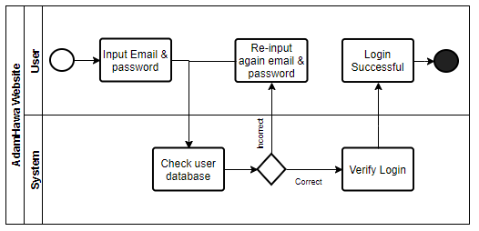

Figure 4.4: User Login

AdamHawa.com provides both searching and matching functionality. In searching, users specify exactly what characteristics they are looking for. They can search the set of profiles based on constrained descriptors such as age, eye colour, and religion, and sometimes by keywords in the free-response descriptors.

In matching, which are slightly less direct, systems pair users by comparing their profile descriptors to the descriptors of others - usually the constrained descriptors, because contemporary techniques for clustering or otherwise identifying similarity work better with clearly defined features than with free text. Different systems apply different weightings to the features of the profiles.

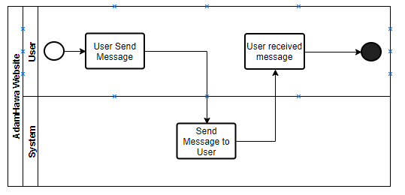

Figure 4.6: Chat.

AdamHawa.com invariably provides a private channel through which members communicate without revealing their names or regular email addresses. Users generally write each other with the private messaging system to find out whether they want to proceed to contact via email, phone, or face-to-face interaction. This provides privacy and safety until the users are comfortable with each other. A smaller group of users maintains contact for an extended period via the private messaging or chatting system as in figure 4.6, either uninterested in migrating the relationship to another medium or unwilling to do so.

The services offered by AdamHawa.com include the project of finding a partner as a whole, starting from finding the appropriate pairing criteria until they decide to set up a marriage. This service includes searching for couples that match the criteria you want and this service is open to Muslims Malaysian citizens aged 18 and above, either single, widowed or widowed and serious in finding a mate. Apart from that, AdamHawa.com provides affordable and attractive wedding packages for couples who will set up a marriage through AdamHawa.com.

## 4.4 Entity Relationship Diagram (ERD)

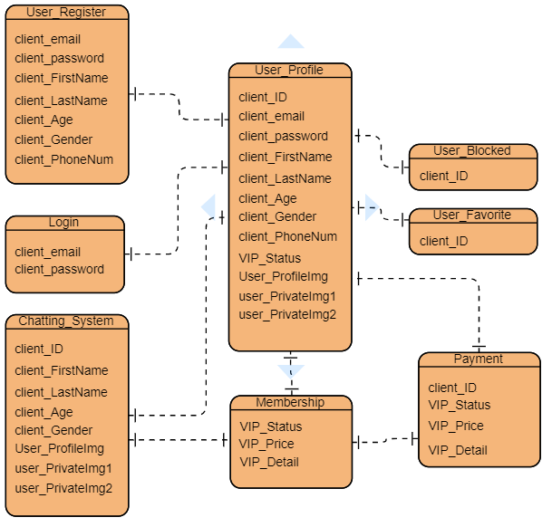

Figure 4.7: Entity Relationship Diagram of AdamHawa.com.

# 5.0 References

Fiore, A.R.T., 2004. *Romantic regressions: An analysis of behaviour in online dating systems* (Doctoral dissertation, Massachusetts Institute of Technology).

(Palo Alto, 1996 – 2019) *Business Plan,*Available at: [*https://www.bplans.com/advertising_agency_business_plan/market_analysis_summary_fc.php*](https://www.bplans.com/advertising_agency_business_plan/market_analysis_summary_fc.php)(Accessed: 04 April 2019).

Pizzato, L., Rej, T., Chung, T., Koprinska, I. and Kay, J., 2010, September. RECON: a reciprocal recommender for online dating. In *Proceedings of the fourth ACM conference on Recommender systems* (pp. 207-214). ACM.

Smith, A.D., 2005. Exploring online dating and customer relationship management. *Online Information Review*, *29*(1), pp.18-33.

# Appendix

# *Website*

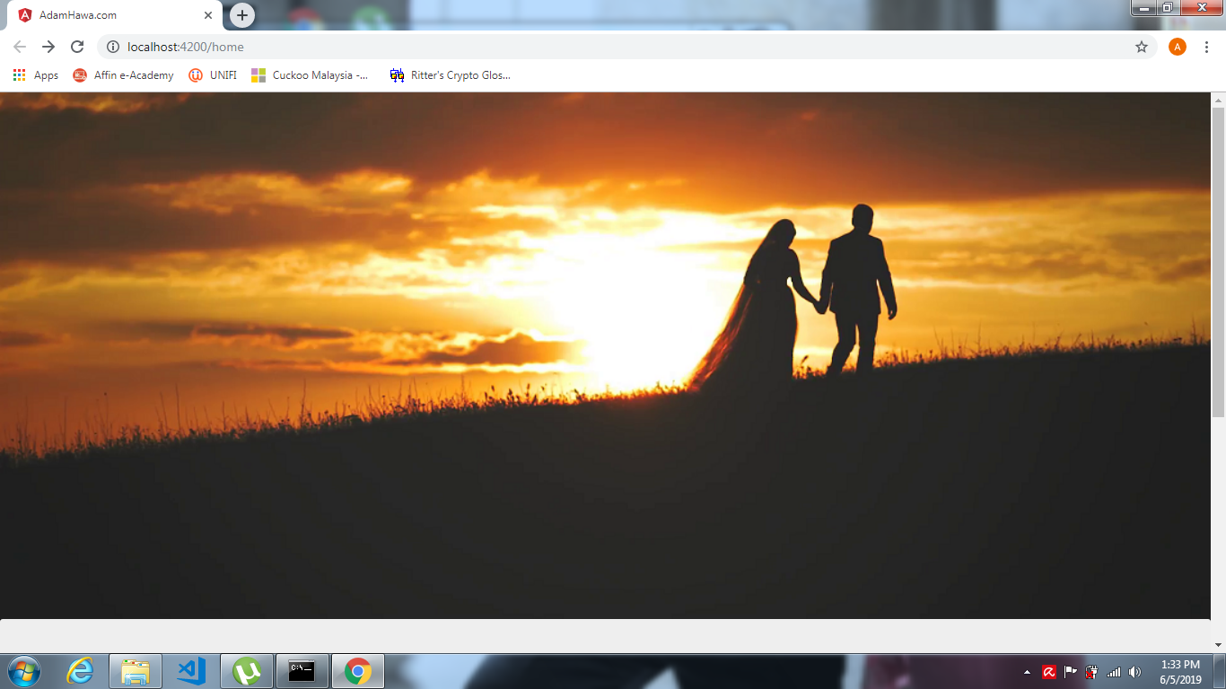

Figure 1 Home Page

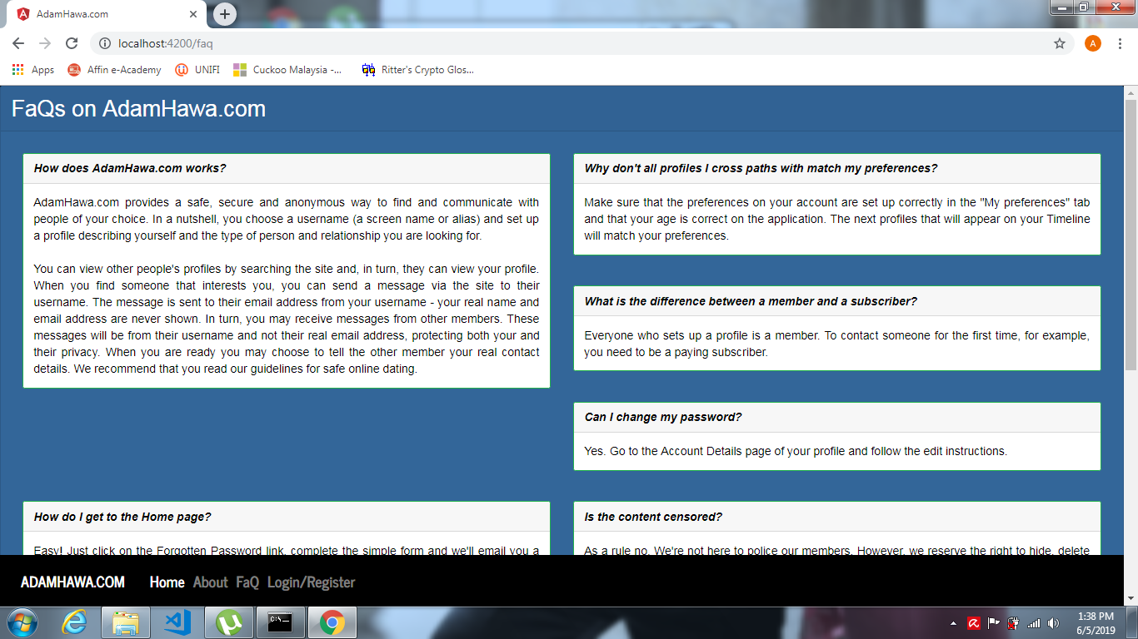

Figure 2 Faq Page

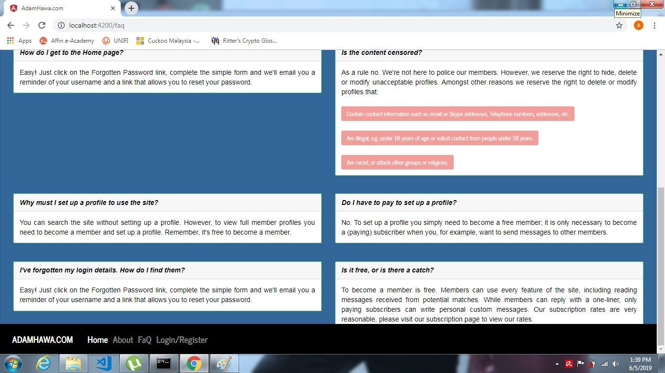

Figure 3 Faq Page 2

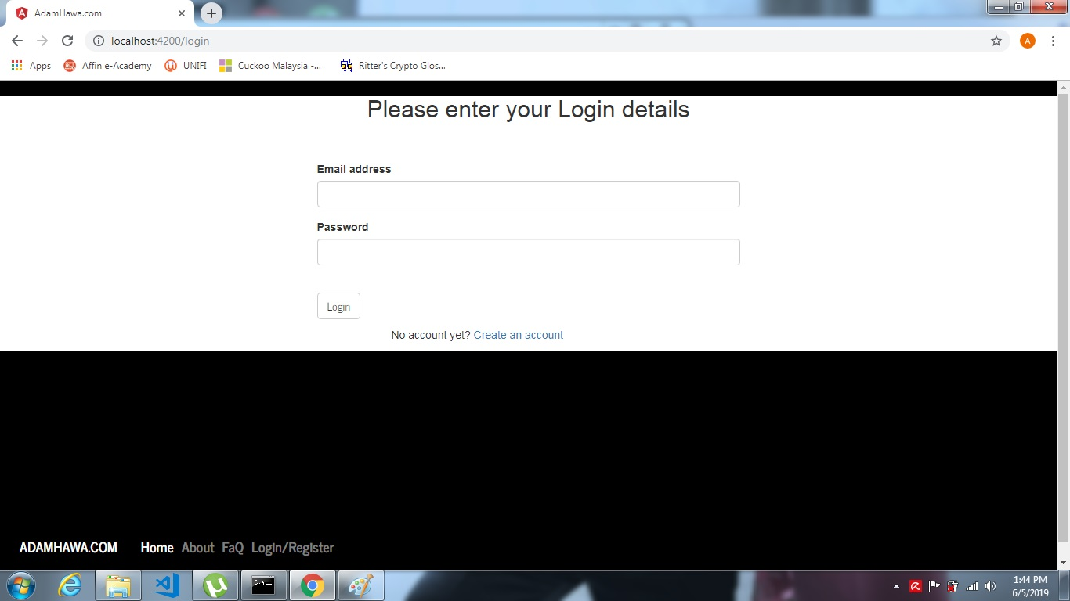

Figure 4 Log InPage

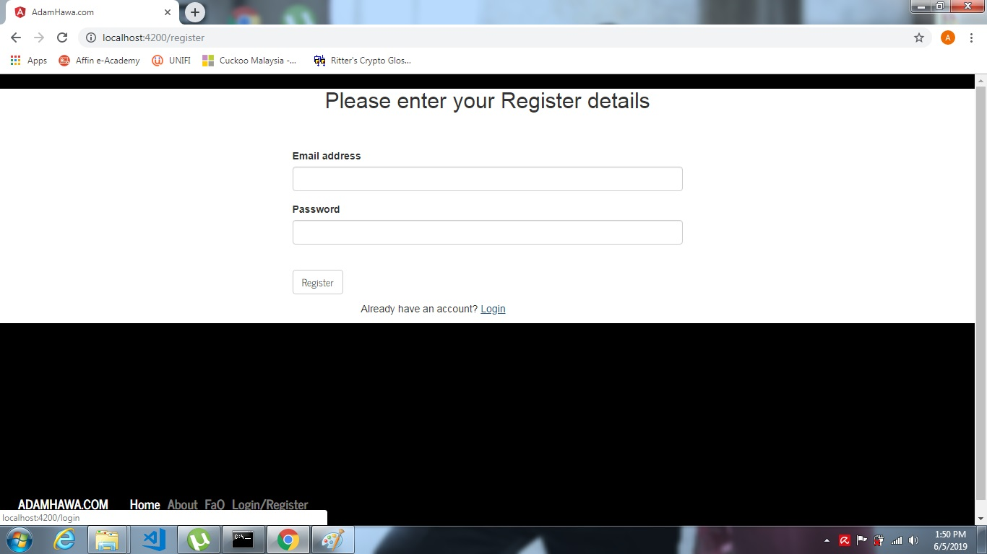

Figure 5 Register Page

# 

Figure 6 About Us Page

# Wireframe

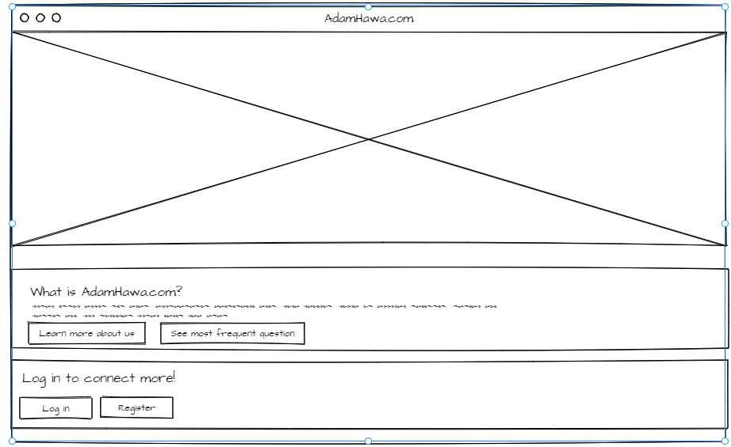

Figure 7- Wireframe for Home Page

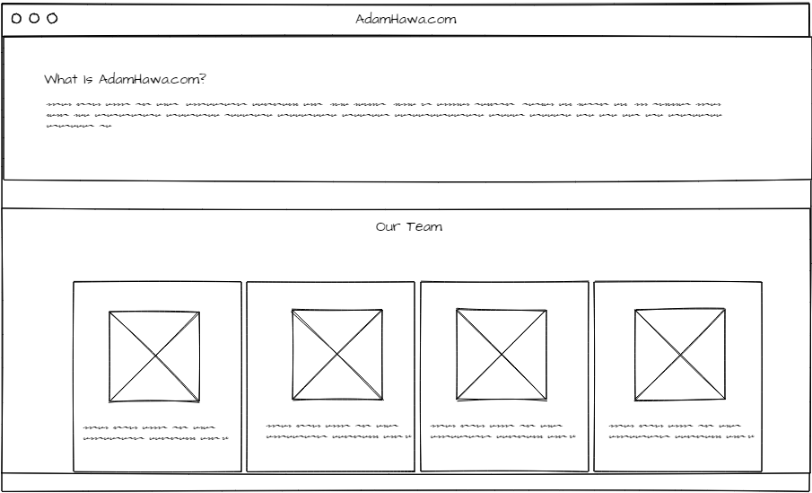

Figure 8 - Wireframe for About Page

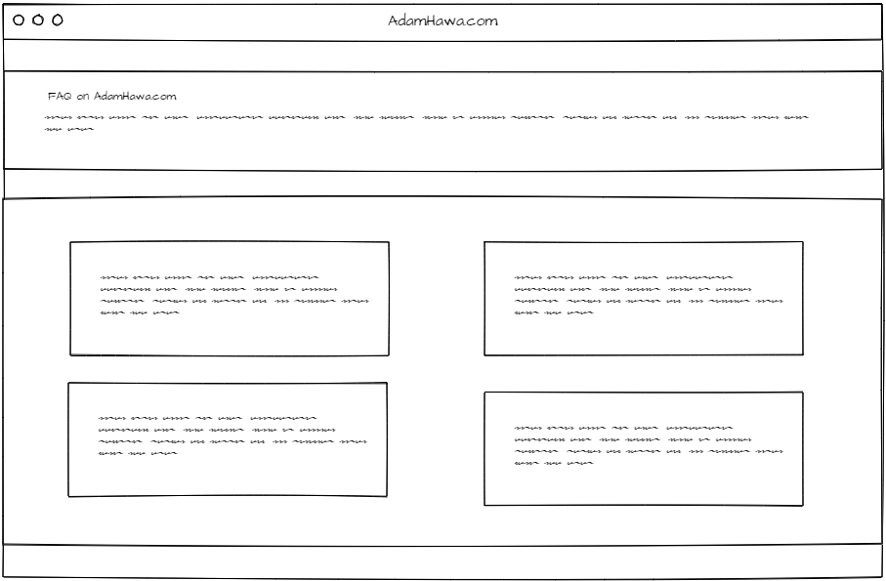

Figure 9- Wireframe for Faq page

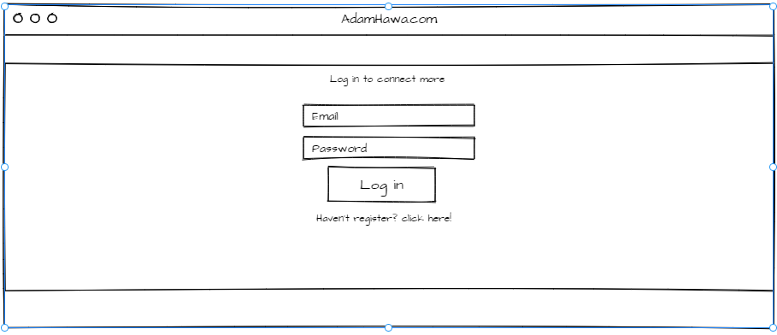

Figure 10- Wireframe for Login Page

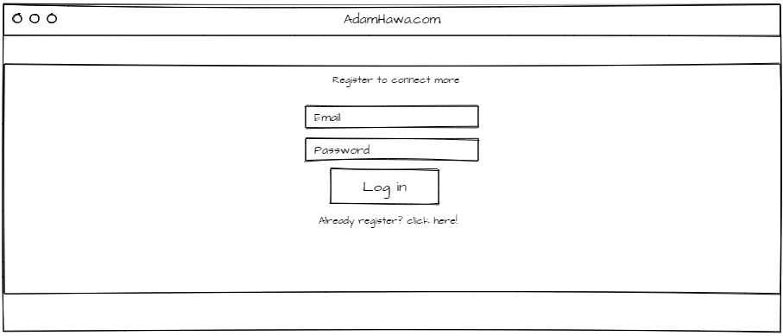

Figure 11- Wireframe for Register Page

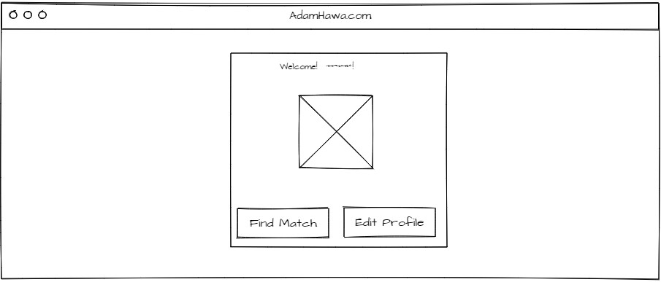

Figure 12- Wireframe for User Page

***Github Collaborators***

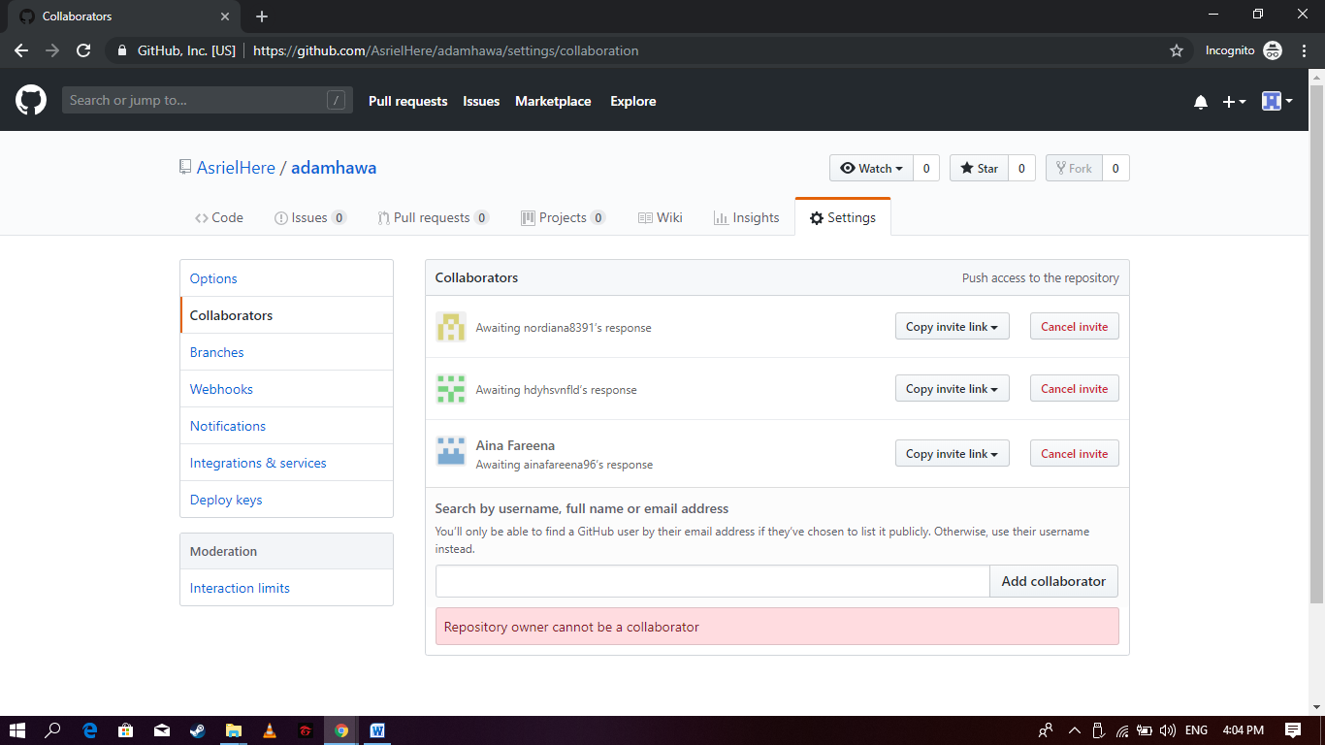

AsrielHere- Ahmad Nadzrin Bin Ibrahim

Hdyhsvnfld – Nur Hidayah binti Samsudin

Ainafareena96 - Aina Fareena binti Mohd Fadzil

Nordiana8391 - Nordiana binti Abdull Rahman

Download link <https://github.com/AsrielHere/adamhawa>